UNIX/LINUX COMMANDS and SHELL SCRIPTING

**What is Unix?**

* Unix Operating system is a set of programs that plays a role as a connection between the computer and the user.
* Users communicates with kernel through a program knows as shell.
* The shell is command line interpreter.

**Key Features**

* **Multiuser support:** UNIX allows multiple users to simultaneously access the same system and share resources.
* **Multitasking:** UNIX is capable of running multiple processes at the same time.
* **Shell scripting:** UNIX provides a powerful scripting language that allows users to automate tasks.
* **Security:** UNIX has a robust security model that includes file permissions, user accounts, and network security features.
* **Portability:** UNIX can run on a wide variety of hardware platforms, from small embedded systems to large mainframe computers.
* **Communication:** UNIX supports communication methods using the write command, mail command, etc.
* **Process Tracking:** UNIX maintains a record of the jobs that the user creates. This function improves system performance by monitoring CPU usage. It also allows you to keep track of how much disk space each user uses, and the use that information to regulate disk space.

**Architecture of Unix OS**

1. Hardware
2. Kernel
3. Shell
4. Application layer

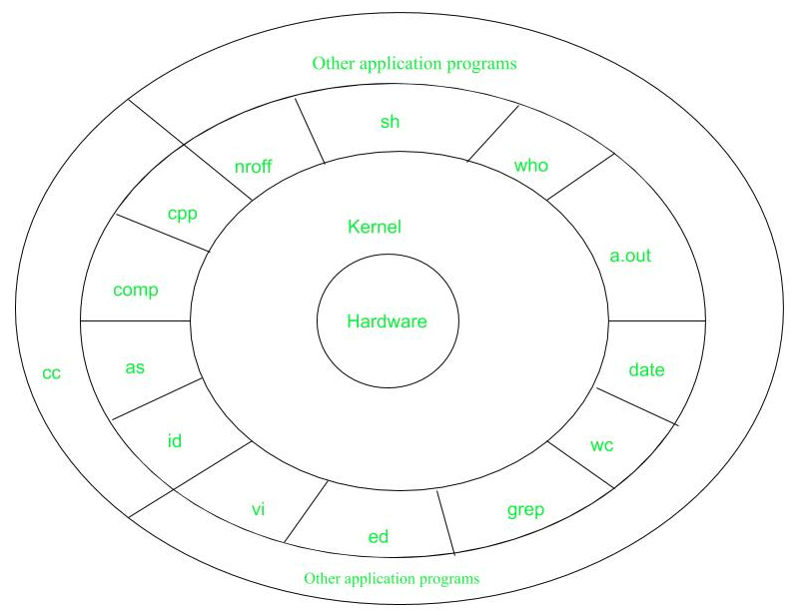

* **Layer-1: Hardware:** It consists of all hardware related information.
* **Layer-2: Kernel:** This is the core of the Operating System. It is a software that acts as the interface between the hardware and the software. Most of the tasks like memory management, file management, network management, process management, etc., are done by the kernel.
* **Layer-3: Shell commands:** This is the interface between the user and the kernel. Shell is the utility that processes your requests. When you type in a command at the terminal, the shell interprets the command and calls the program that you want. There are various commands like cp, mv, cat, grep, id, wc, nroff, a.out and more.
* **Layer-4: Application Layer:** It is the outermost layer that executes the given external applications.

What is Linux?

* Linux is an open-source Unix-like operating system-based family on the Linux kernel.
* The Linux Kernel is like the brain of the operating system because it manages how the computer interacts with its hardware and resources.
* It is not just limited to the operating system, but nowadays, it is also used as a platform to run **desktops, servers, and embedded systems.**
* Linux system is used to manage various services such as **process scheduling, application scheduling, basic peripheral devices, file system, and more**.
* [Linux](https://javatpoint.com/linux-tutorial) provides various advantages over other operating systems such as Windows and macOS. So, it is used in almost every field, from cars to home appliances and smartphones to servers (supercomputers).

**Why is Linux better than other operating systems?**

1. Open Source.
2. Security
3. Free availability (GNU GPL)
4. Lightweight
5. Stability
6. Performance
7. Flexibility
8. Software Update
9. Distributions (**Ubuntu, Fedora, Debian, Linux Mint, Arch Linux)**
10. Suitable for programmers
11. Privacy and Compatibility
12. Multitasking

**Key Features**

* Multiuser capability: Multiple users can access the same system resources like memory, hard disk, etc. But they have to use different terminals to operate.
* **Multitasking:** More than one function can be performed simultaneously by dividing the CPU time intelligently.
* **Portability**: Portability doesn't mean it is smaller in file size or can be carried in pen drives or memory cards. It means that it support different types of hardware.
* **Security**: It provides security in three ways namely authenticating (by assigning password and login ID), authorization (by assigning permission to read, write and execute) and encryption (converts file into an unreadable format).
* **Live CD/USB:** Almost all Linux distros provide live CD/USB so that users can run/try it without installing it.
* **Graphical User Interface (X Window system):** Linux is command line based OS but it can be converted to GUI based by installing packages.
* **Support's customized keyboard:** As it is used worldwide, hence supports different languages keyboards.
* **Application support:** It has its own software repository from where users can download and install many applications.
* **File System:** Provides hierarchical file system in which files and directories are arranged.
* **Open Source:** Linux code is freely available to all and is a community-based developmentproject.

**Linux Bash**

The Linux Bash is also known as **‘Bourne-again Shell’.** It is a **command language interpreter** for the Linux based system. The Linux/Unix shell allows us to interact with the Linux system through the commands. It let us invoke an executable file to create a running process. It is designed in such a way that we can perform all the Linux operations through Bash.

The Bash is a command language interpreter as well as a programming language. It supports **variables, functions, and flow control, like other programming languages**. It can also read and execute the commands from a file, which is called a shell script.

**Difference between Linux and Unix? (Most Imp Interview questions)**

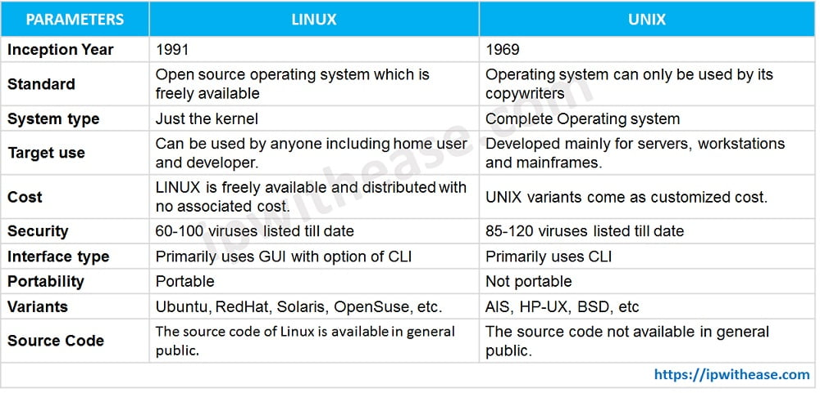

**In Simple Terms:**

* Unix is an older, more rigid system that is typically used in big corporations with expensive licensing.
* Linux is a modern, flexible, and free alternative that is used widely across different industries, from servers to personal computers.

**Key Difference in One Line**:  
 "Unix is proprietary and older, while Linux is open-source, modern, and more versatile."

**Difference between Linux and Windows? (Most Imp Interview questions)**

**In Simple Terms:**

* **Linux**: Great for coding, servers, and advanced users.
* **Windows**: Best for gaming, home, and office use.

**Key Difference in One Line**:  
 “Linux is for techies and servers; Windows is for everyday users and gaming!”

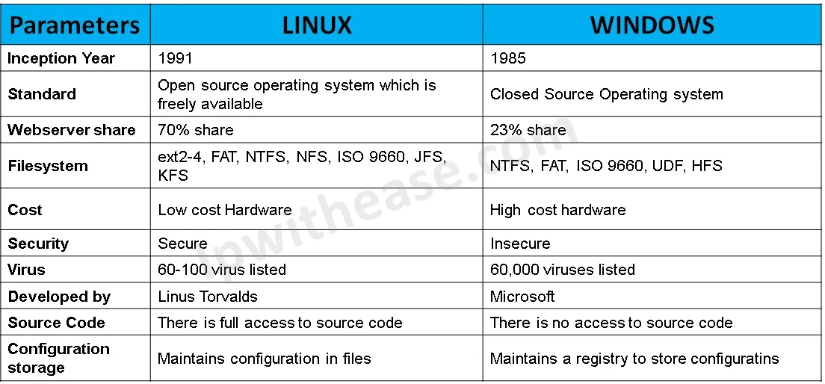

**Linux Commands**

**What are Commands?**

A command is an instruction given to our computer by us to do whatever we want. Commands written in Mac OS, and Linux is called as terminal, whereas, in windows it is called as command prompt. Commands are always case sensitive. Default shell in Linux is called bash (Bourne-Again Shell). There are two types of shell commands:

* **Built-in shell commands:** They are part of a shell. Each shell has some built in commands. (e.g., cd, echo, pwd)
* **External/Linux commands**: Each external command is a separate executable program written in C or other programming languages. (e.g., ls , awk , grep).
* **Alias** **Commands:** Aliases are shortcuts for long commands, created by the user.

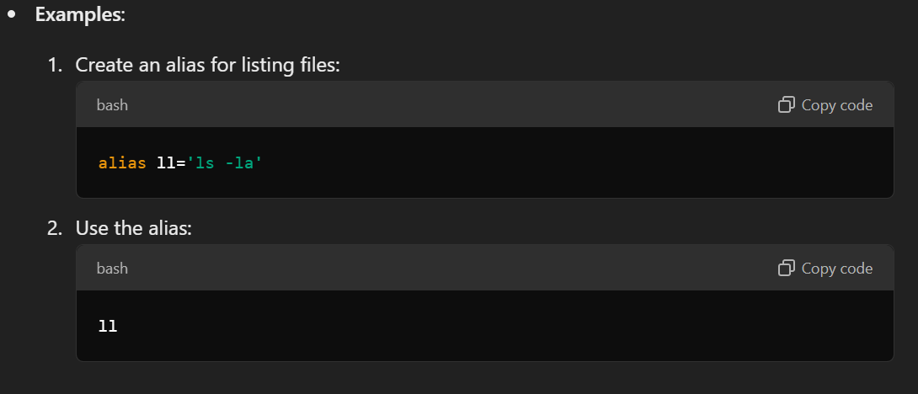

* **User-defined Commands (Functions):** These are custom commands created by writing shell functions or scripts.

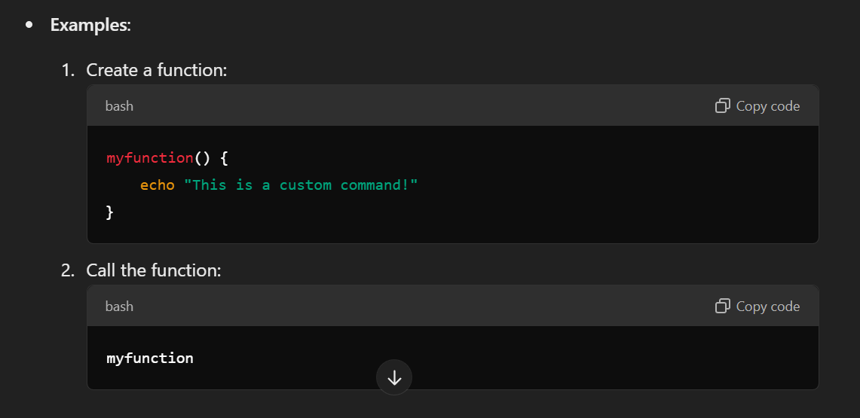

* **Meta or Control Commands:** These control how commands run or interact.

Now lets us learn in detail about all the Linux command.

NOTE: There is a documentation for all Linux Command and their complete information.

You can access the document from our git repository.

GIT URL: [https://github.com/DivyaNaragund18/Unix-Linux-Shell-Scripting-.git](https://github.com/DivyaNaragund18/Unix-Linux-Shell-Scripting-.git%20)